**Specification Sheet**

**Project:**

Design of new evaporator for 3x 150g R-290 integral display case

**Scope:**

For an ongoing project regarding a R-290 integral display case, the scope is to optimize the system components, along with the evaporator. The current display case is equipped with 3x 150gr R-290 refrigeration circuits (see Figure 1), each of them working with a Copeland Scroll ZB09KAU-TFD compressor, which is a fixed speed, vertical design compressor.

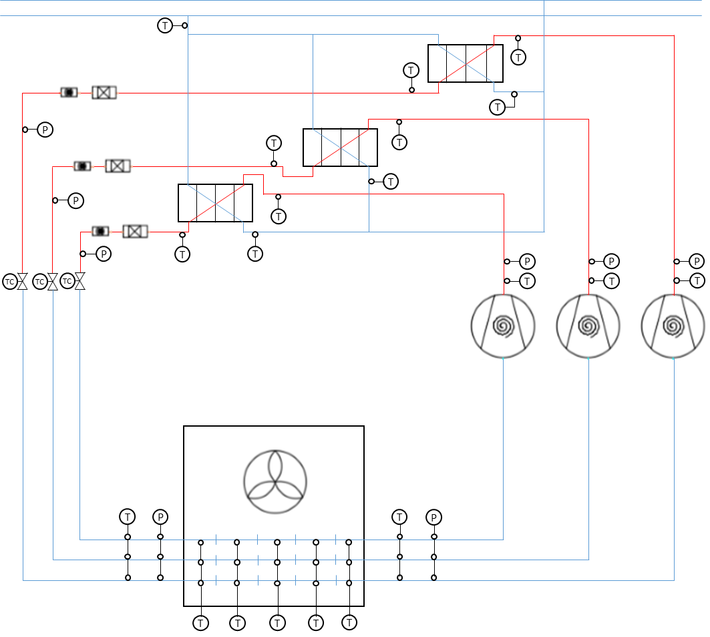

Figure 1: System overview with three circuits filled with 150 g R-290

**Objective:**

The objective is to

* optimize the performance of the current evaporator,
* while keeping the current external volume (for retro-fit reasons) and
* reducing the refrigerant charge.

This can potentially be done by reducing the pipe size and incrementing congruously the number of pipes to get the same cooling capacity or by re-arranging the circuits configuration.

**Design point/working conditions:**

• Tevap: – 6 °C  
• Cooling capacity per compressor/circuit: 2.5 kW  
• Condensing temp: 40 °C  
• Subcooling: 1 K  
• Superheat: 7 K to 10 K  
• Number of circuits: 3  
• Massflow R-290 per circuit: 9.20 g/s  
• Tair,out: – 1 °C  
• Tair,in: 6 °C; 50% R.H.

**Current evaporator design:**

• Dimensions: H 400 mm; W 3400 mm; D 100 mm. A more detailed view of the current evaporator design can be found in Attachment B.

• Fin spacing: 5 mm

• current pipe Ø: 3/8”

The current evaporator design is a one block evaporator with 3 independent circuits. Actual measurements show a pressure drop of 0,4 to 0,6 bar. This might be due to the long pipe length per circuit (6x3,4 m = 20,4 m) and the high velocity of the refrigerant (currently 20 – 24 m/s).

|  |  |
| --- | --- |
|  |  |
| 3 circuits with 6 passes,  long evaporator pipe length of 20 m per circuit 🡪 creates big pressure drop 🡪 low efficiency | distribute each circuit 3 times to two passes 🡪 shorter pipe length per circuit 🡪 lower velocity  reduces the losses and increases the COP  actual improvement needs to be evaluated experimentally |

Figure 2: Current evaporator with 6 passes per circuit (left) and planned design for new evaporator

For the improved version of the evaporator it is an idea to utilize a distributor to separate the flow. With the current evaporator design (pipe Ø = 3/8”) the refrigerant velocity would drop to 6 m/s. As this might lead to oil return problems it is suggested to use a pipe diameter of ¼” (or any other size between 6mm and 8 mm), which would lead to a more acceptable velocity of 12-15 m/s. Decreasing the pipe diameter would also reduce the total refrigerant charge of the system.

The air flow is generated by 6 diagonal flow EC fans, model K1G-200 from EBM Papst running at 1400 rpm in the current version. For the next version, the same fans will be used, but Modbus feature will be added to be able to operate each fan independently between 0 to 2200 rpm. A curve of the fan performance and a representative schematic of the air flow can be found in Attachment A.

**New evaporator design:**

Regarding the new design of the evaporator it is planned to utilize a flow distributor as mentioned. Other than that, also other suggestions will be considered for the new design evaluation. Therefore, please feel free to submit your design proposals to improve the evaporator with respect to the objectives.

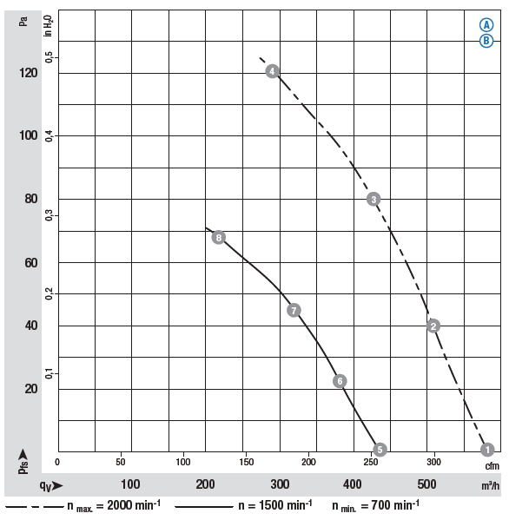

EBM-Papst K1G-200 curves

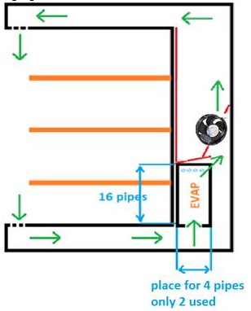

Representative schematic of air flow through display case

